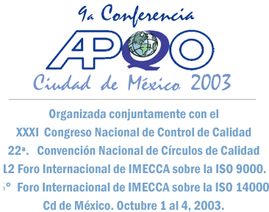 News Release

Asian Pacific Quality Organization
45 Hybrid St., Phase IV
Greenwoods Executive Village
Cainta Rizal, PHILIPPINES

Contact: Charles Aubrey
1-815-387-4970
caubrey@andpkg.com

Asia Pacific Quality Organization Announces Winners of World Class Performance-International Asia Pacific Quality Awards

Best Performing Organizations in the World

Chicago, Illinois, USA July 17, 2009- Asia Pacific Quality Organization (APQO) today announced The World Class Winners of the International Asia Pacific Quality Awards.

“We are pleased to announce that six organizations from Asia and the Pacific Rim are being recognized as exemplary companies of world class quality performance. They have achieved the highest International Asia Pacific Quality Award modeled after the U.S. Malcolm Baldrige Performance Excellence Award” said Charles Aubrey, Chairman of APQO and the International Asia Pacific Quality Award Executive Committee.

The following organizations have won the World Class Award (Highest):
Large Manufacturing:
Vietnam Electric Cable Corporation, HoChiMinhCity, Vietnam; Mr. Hoang Nghia Dan, Chairman and General Director

Orel Manufacturing, Colombo 02, Sri Lanka; Mr. Kushan Kodituwakku, Managing Director

Large Service:
Hindalco Indusries LTD., Uttar Pradesh, India; Mr. Debu Bhattacharya, Managing Director

Small Service:
Shanghai Investment Consulting Corporation, Shanghai, China; Mr. Zhu Zhaosong, General Manager

Education:
Colegio Compoverde, Colinas De Santa Barbara, Mexico; Mr. Jose Manuel Costa Lavin, General Director

Not for Profit:
Hidroelectric Power Plant, San Joaquin Queretaro, Mexico; Mr. Ing Ramiro Sanchez Flores, Superintendent

The following four organizations won the Best in Class Award (Second highest):
Large Manufacturing:
Marico Limited, Mumbai, India; Mr. Saugata Gupta, CEO

Large Service:
Material-Petroleum Joint Stock Company(COMECO), HoChiMinh City, Vietnam; Mrs. Truong Duc Hanh, President and General Director

Small Service:
Port of Lazaro Cardenas, Michoacan, Mexico; Mr. Ruben Medina Gonzalez, CEO
Venture Infotek Global Limited, Mumbai, India; Mr. Piyush K. Khaitan, Managing Director and Vice-Chairman

Education:
Global Indian International School, Singapore; Mr. Atul Temurnikar, Chairman

Finally the following organization won the Quest for Excellence Award (Third highest):
Health Care:
Dr. H. L. Hiranandani Hospital, Mumbai, India; Dr. Sujit Chatterjee, CEO

The awards will be presented at the 15th APQO/ International Conference in Mexico City, Mexico on October 7-10, 2009. For more information please visit: www.imecca.org.mx or e-mail: dg@imecca.org.mx.

This is the ninth year of the International Asia Pacific Quality Awards process.

About the Asia Pacific Quality Organization (APQO)
The APQO was founded and organized by National Quality Organizations in Asian and Pacific Rim countries including the American Society for Quality and was incorporated in the Philippines in 1985. It is a non-profit organization formed to be a primary mover for quality and continuous improvement for goods and services and quality of life in the Asia Pacific Region. APQO has several hundred National Quality Organizations (Core members), Corporate members, and Individual members. For more information about APQO and the International Asia Pacific Quality Award visit www.apqo.org.

# # #

